**Supporting Information template**

Please use this template when formatting and submitting your Supporting Information.

This template serves as both a “table of contents” for the supporting information for your article and as a summary of files.

**Once you have completed this template, you should delete this instruction page.**

**Overview**

Please note that all supporting information will be peer reviewed with your manuscript. For more information, please see the Supporting Information Guidelines in Author Resources

**Using this Template**

Type or paste the appropriate text (title, author list, and corresponding authors) into the template below.

Contents of this document:

* All Supporting text and figures should be included in this document.
* Tables may be included, but can also be uploaded separately, especially if they are larger than one page, or if necessary for retaining table formatting.
* Data sets, large tables, movie files, and audio files should be uploaded separately, following AGU naming conventions. File name and descriptions for these should be included in this template.
* All references should be included in the reference list of the main paper so that they can be indexed, linked, and counted as citations. The reference section does not count toward length limits.

How to fill out this document:

* Insert supporting information content into each appropriate section of the template.
* Figures and tables should appear above each caption.
* To add additional captions, simply copy and paste each sample caption as needed.
* You will be prompted to upload these files on the Upload Files tab during the submission process, using file type “Supporting Information (SI)”



*Global Biogeochemical Cycles*

Supporting Information for

Efficient flux transfer through the Eastern Tropical North Pacific Oxygen Deficient Zone likely due to slow particle remineralization rather than suppressed disaggregation

Jacob A. Cram1, Clara A. Fuchsman1, Megan E. Duffy2, Jessica L. Pretty3, Rachel M. Lekanoff3, Jacquelyn A Neibauer2, Shirley W. Leung2, Klaus B. Huebert1, Thomas S. Weber4, Daniele Bianchi5, Natalya Evans6, Allan H. Devol2, Richard G. Keil2, Andrew M.P. McDonnell3

1Horn Point Laboratory, University of Maryland Center for Environmental Science, Cambridge, MD, USA.

2School of Oceanography, University of Washington Seattle, Seattle, WA, USA.

3College of Fisheries and Ocean Sciences, University of Alaska Fairbanks, Fairbanks, AK, USA.

4School of Arts and Sciences, University of Rochester, Rochester, NY, USA.

5Department of Atmospheric and Oceanic Sciences, University of California Los Angeles, Los Angeles, CA, USA.

6Department of Biological Sciences, University of Southern California, Los Angeles, CA, USA.

**Contents of this file**

Text S1 to Sx

Figures S1 to S

Tables S1 to Sx

**Additional Supporting Information (Files uploaded separately)**

Caption for Text S1

**Introduction**

This file contains supplemental figures referenced in the manuscript. It also contains a caption for a .PDF file containing mathematical equations underpinning the particle remineralization model used.

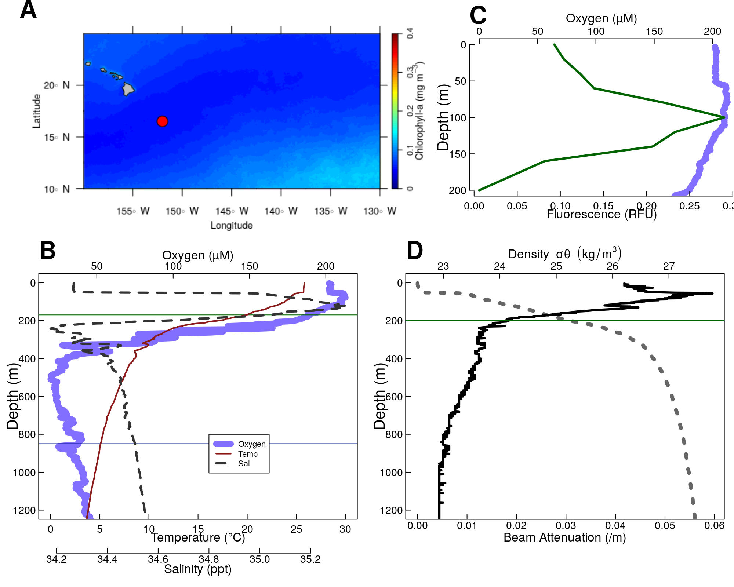

**Figure S1**. Physical and chemical data from P16 Station 100. Located at 16.5°N 152.0°W. (A) Map of the nearby tropical pacific station P6 Station 100. Colors indicate chlorophyll concentrations at the surface, averaged over all MODIS images. The red circle indicates the location of Station P2. (B-D) Oceanographic parameters. The thin horizontal green line shows the location of the base of the photic zone (200m m). (**B)** Oxygen temperature and salinity. (**C)** Oxygen, and fluorescence. Because the fluorometer was broken on this cruise, fluorescence data were pulled from world ocean atlas (Garcia et al. 2014).**(D)** Beam attenuation and density, calculated from the salinity temperature and pressure data.

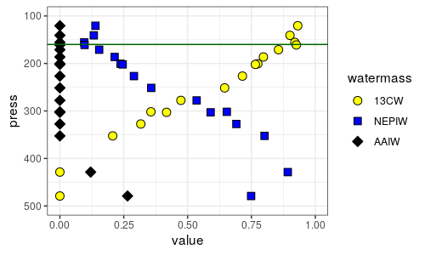

**Figure S2.** Water mass analysis at St P2 indicates the relative contributions proportions of the three primary water masses at this site, ${13}^{∘}C$ water (13CW), North Equatorial Pacific Intermediate Water (NEPIW) and Antarctic Intermediate Water (AAIW). Values indicate relative contributions of each water mass and are scaled so as to sum to one. Data are taken directly from Evans et al. (2020).

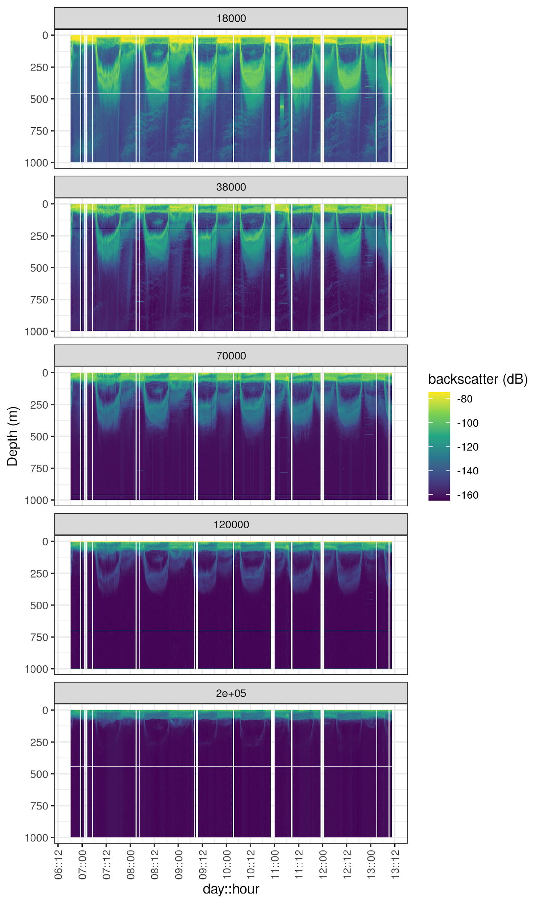

**Figure S3.** Acoustic data, measured by EK60, measured over the course of the experiment. Shown are data from the all frequency bands. Values are in return signal intensity and have not been normalized to observed biomass.

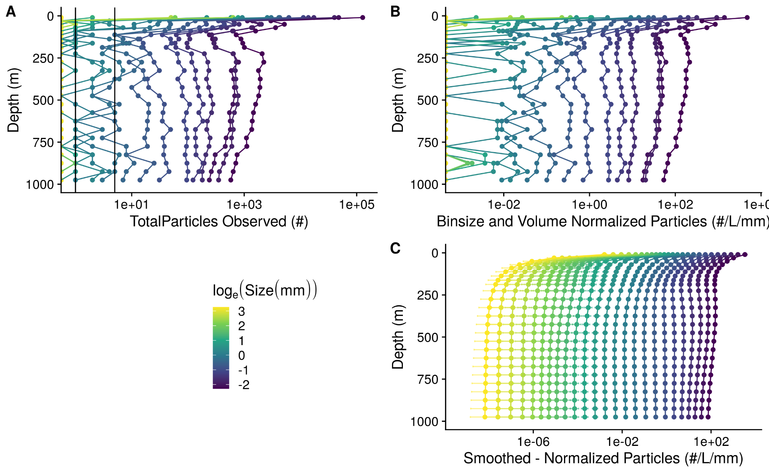

**Figure S4.** A profile of particle abundances at different sizes and depths, collected on January 13 beginnin at 06:13. **(A)** Numbers of observed particles. As the x axis is log transformed, zeros are indicated as points along the Y axis. Vertical black lines indicate 1 and 5 observed particles, respectively. **(B)** Particle numbers normalized to volume sampled and particle size bin width. **(C)** Smoothed and extrapolated particle abundances, based on a negative binomial GAM that predicts particle abundance form size and depth.

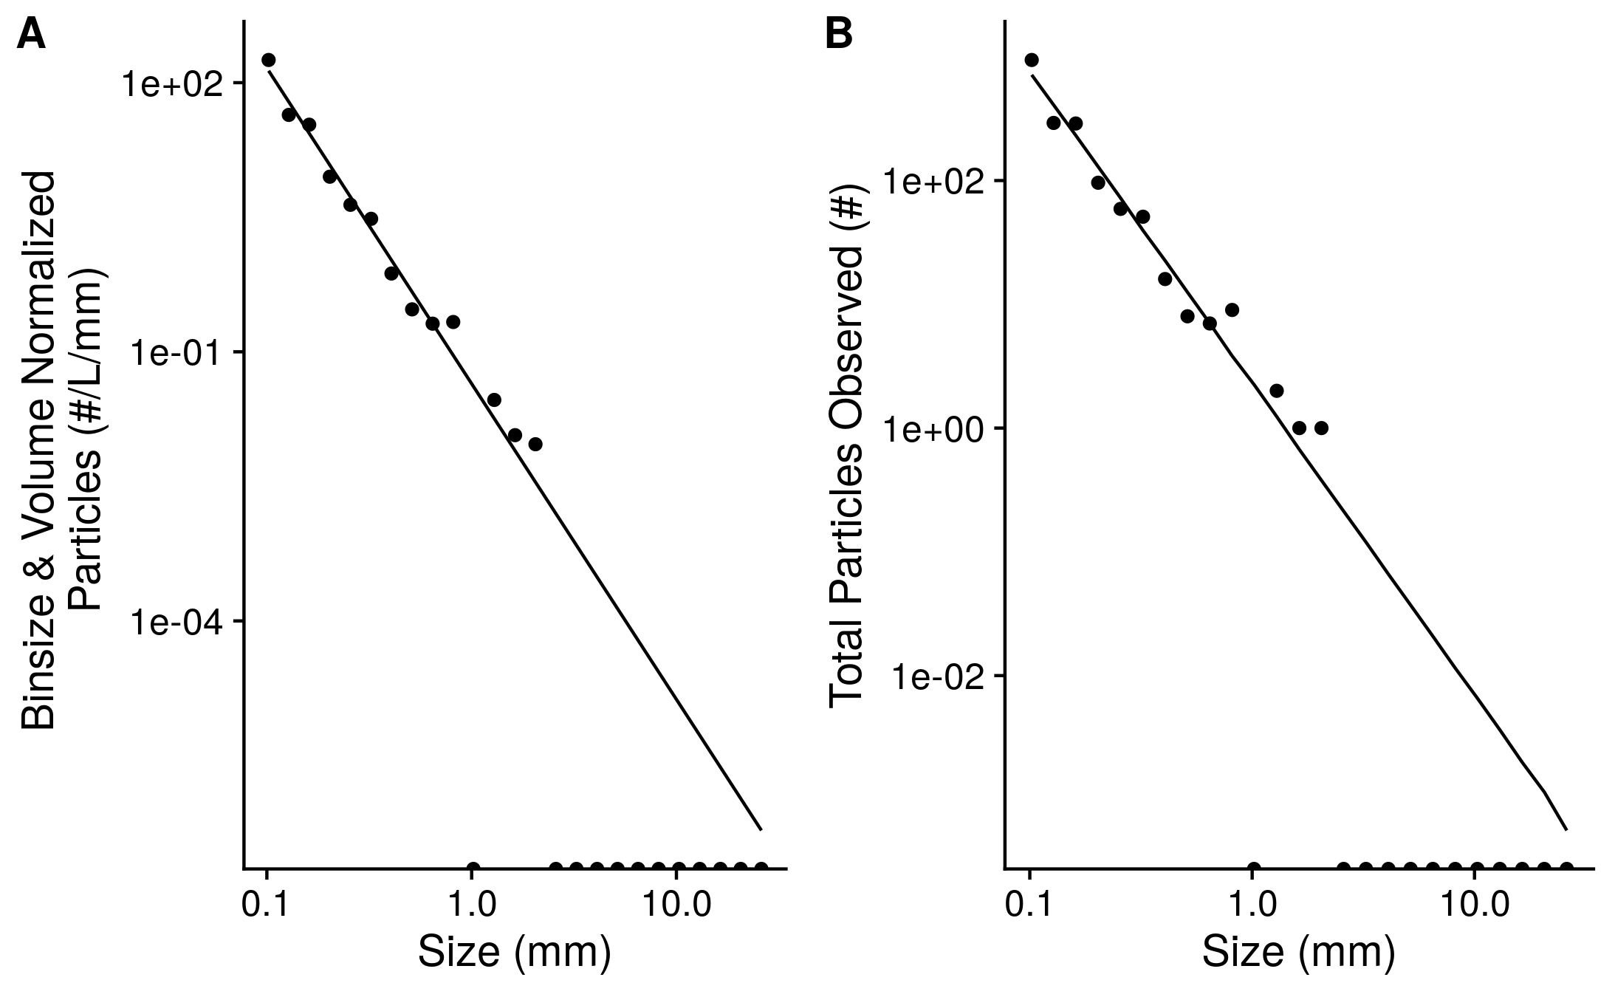

**Figure S5.** An example of observed particle size distribution spectra. These are depth binned data from between 150 and 175 m deep in the water column from the cast that occurred at *2017-01-13 17:51* local time. This depth bin contains total numbers of particles that were seen across 206.8 L of merged UVP image volume. Points indicate **(A)** total numbers of observed particles and **(B)** particle numbers normalized to volume sampled and particle size bin width. Half-dots along the x axis correspond to particle size bins in which zero particles were observed. The line indicates the predicted best fit line of the data. The line was fit on the binsize and volume normalized data by a negative-binomial general linear model. The line in panel **A** indicates predictions from this same model, re-scaled into absolute particle space.

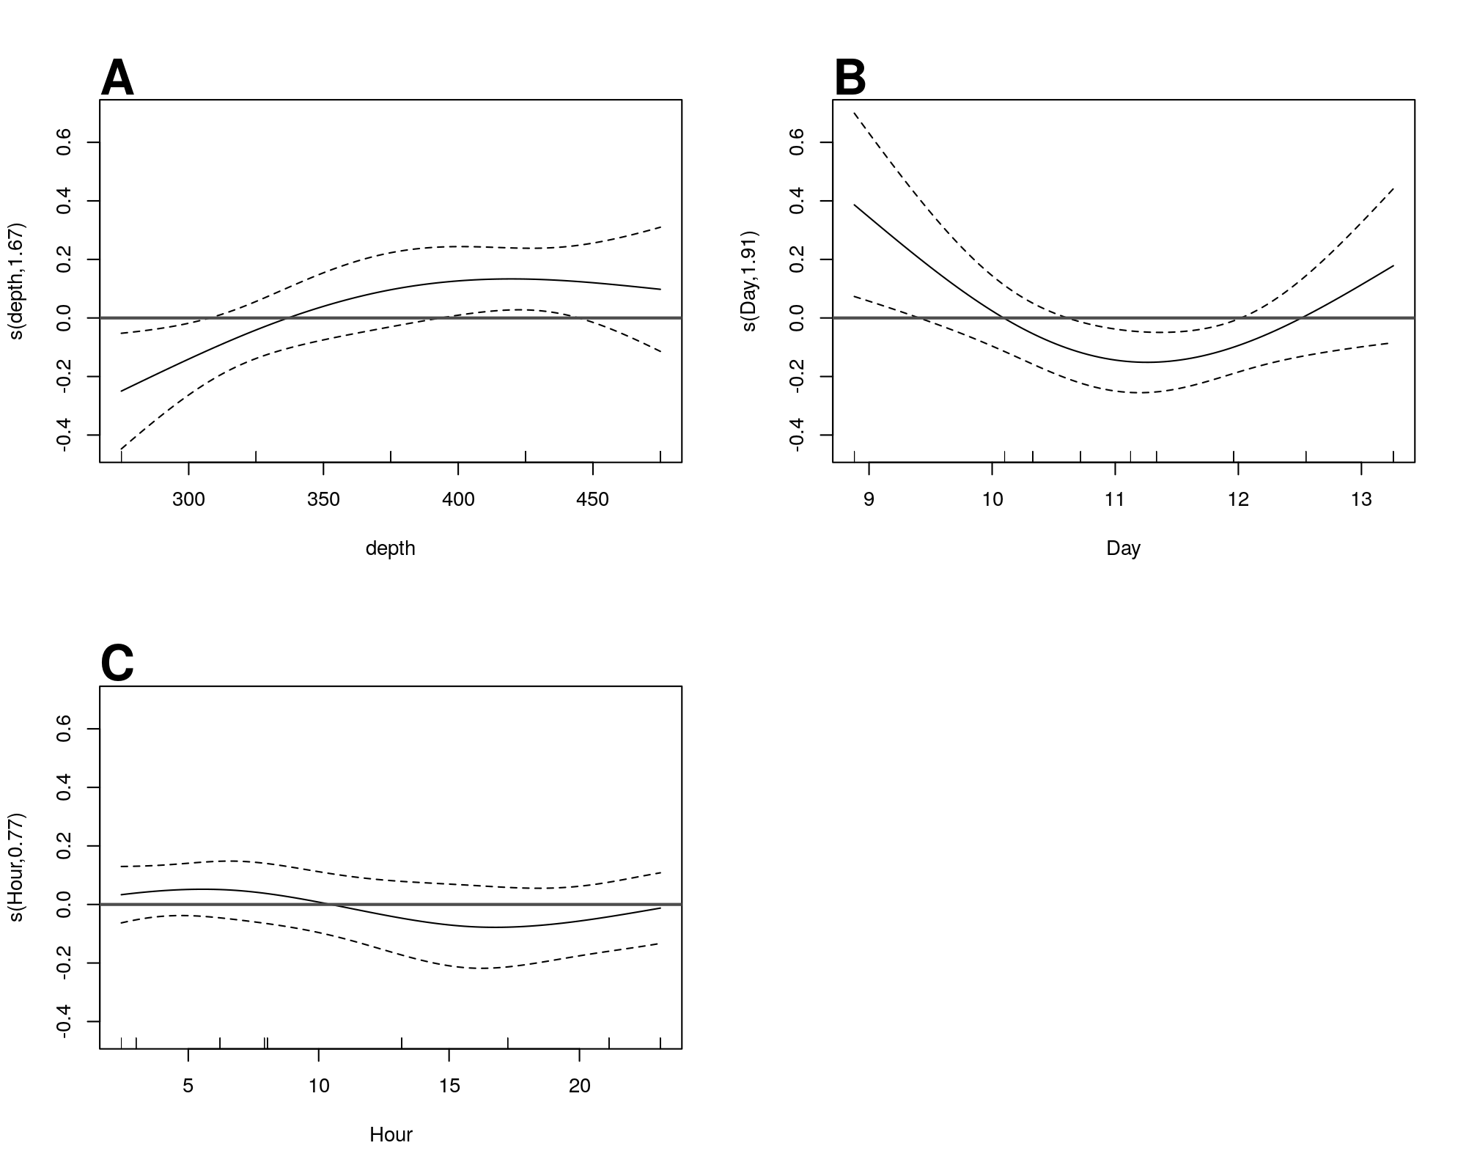

**Figure S6.** GAM predicted effects of **A** Depth, **B** Day of the month in January 2017, and **C** hour of the day on the fifth-root transformed, depth normalized, rate of change of flux. Y axis indicates the value of the component smooth functions effect on Flux. Positive values associate with times and regions of the water column where flux is increasing, holding other factors constant, and negative ones where it is decreasing. Horizontal gray line indicates y = 0, corresponding to that parameter having zero effect, positive or on the outcome. Only Depth has a statistically significant relationship to rate of change of flux (see section X).

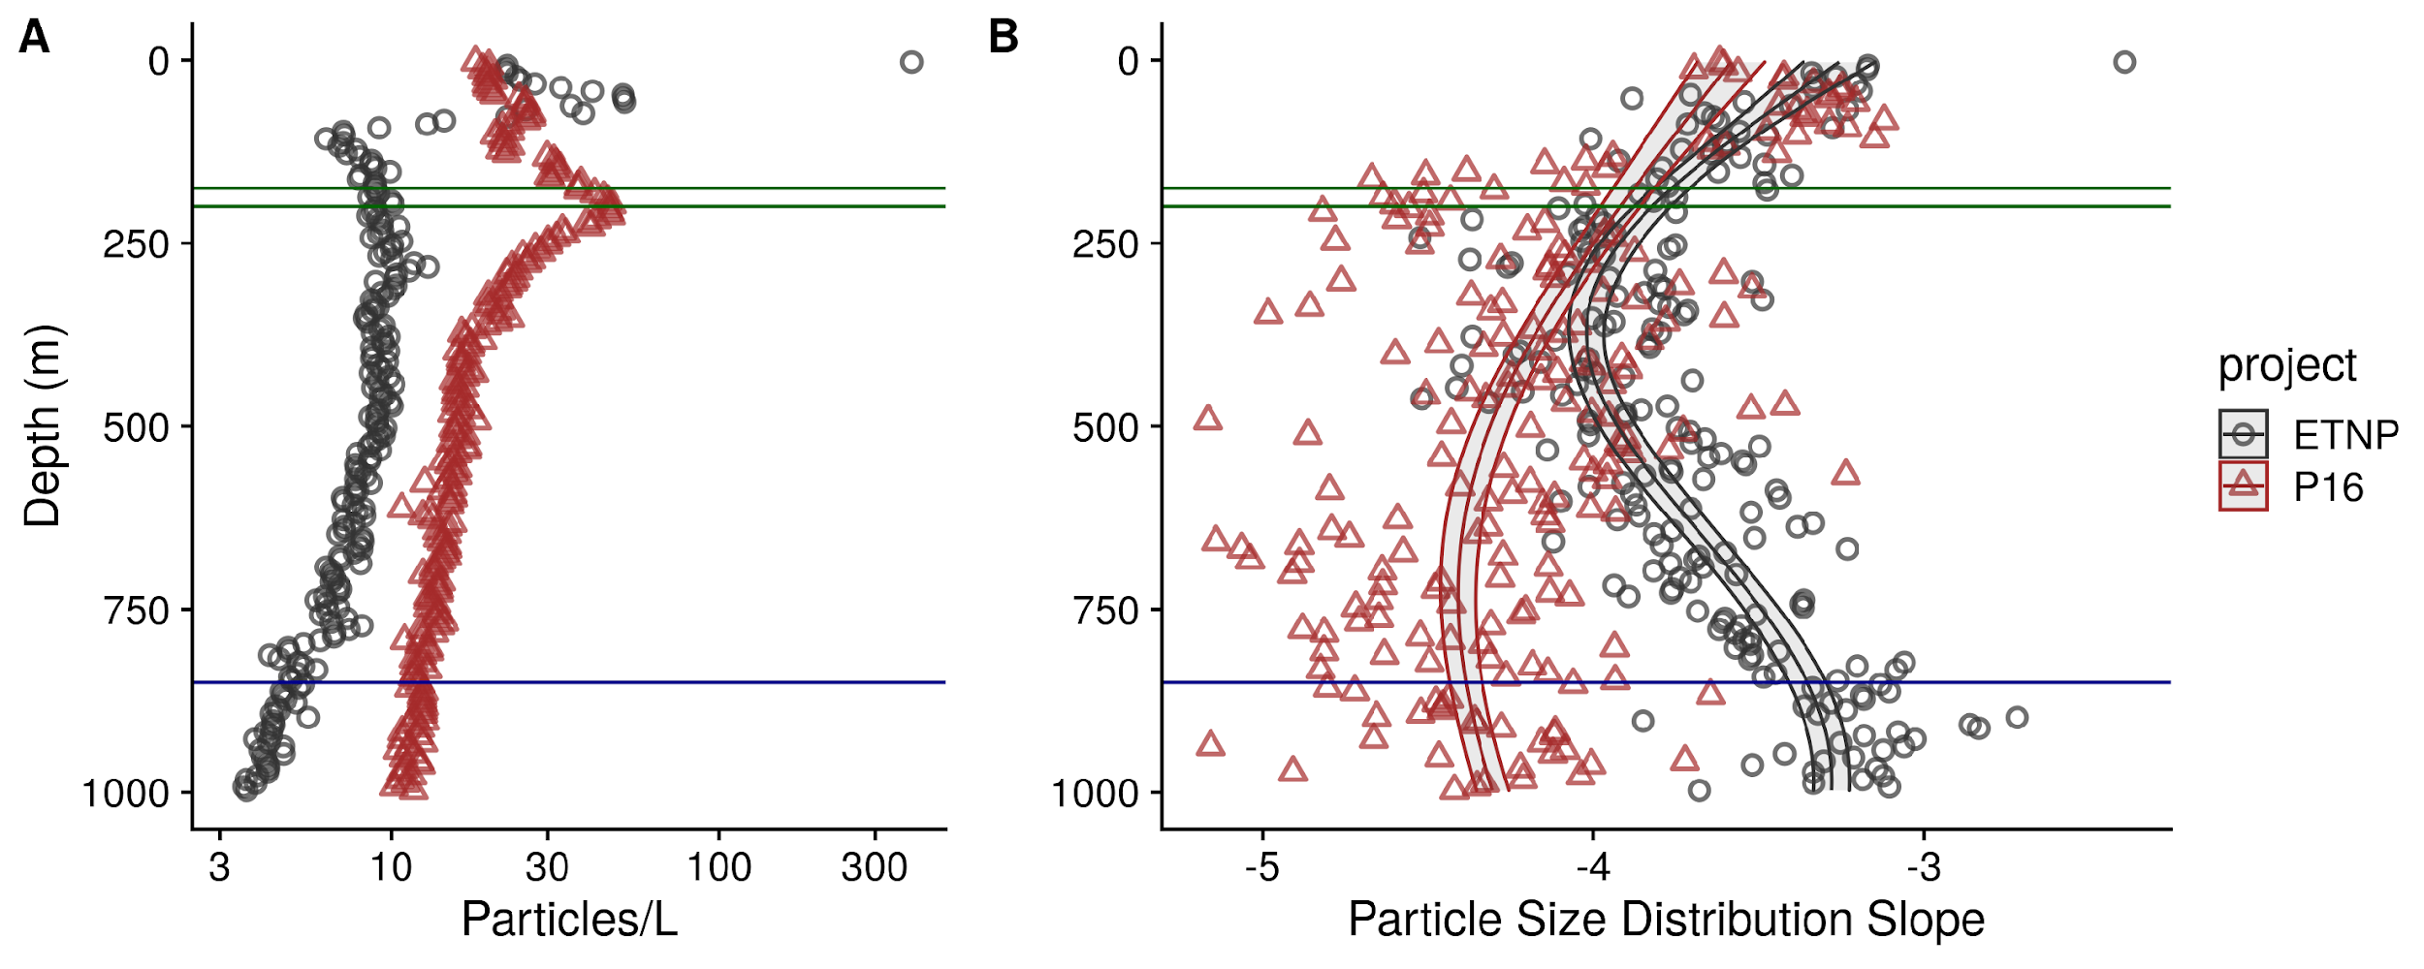 **Figure S7**. As above, but for the final cast taken at ETNP station P2 and the only cast collected from the P16 transect at the station 100. P16 Station 100 was chosen because it is at a similar latitude to ETNP station P2. (A) Total particle numbers, (B) Particle size distribution.

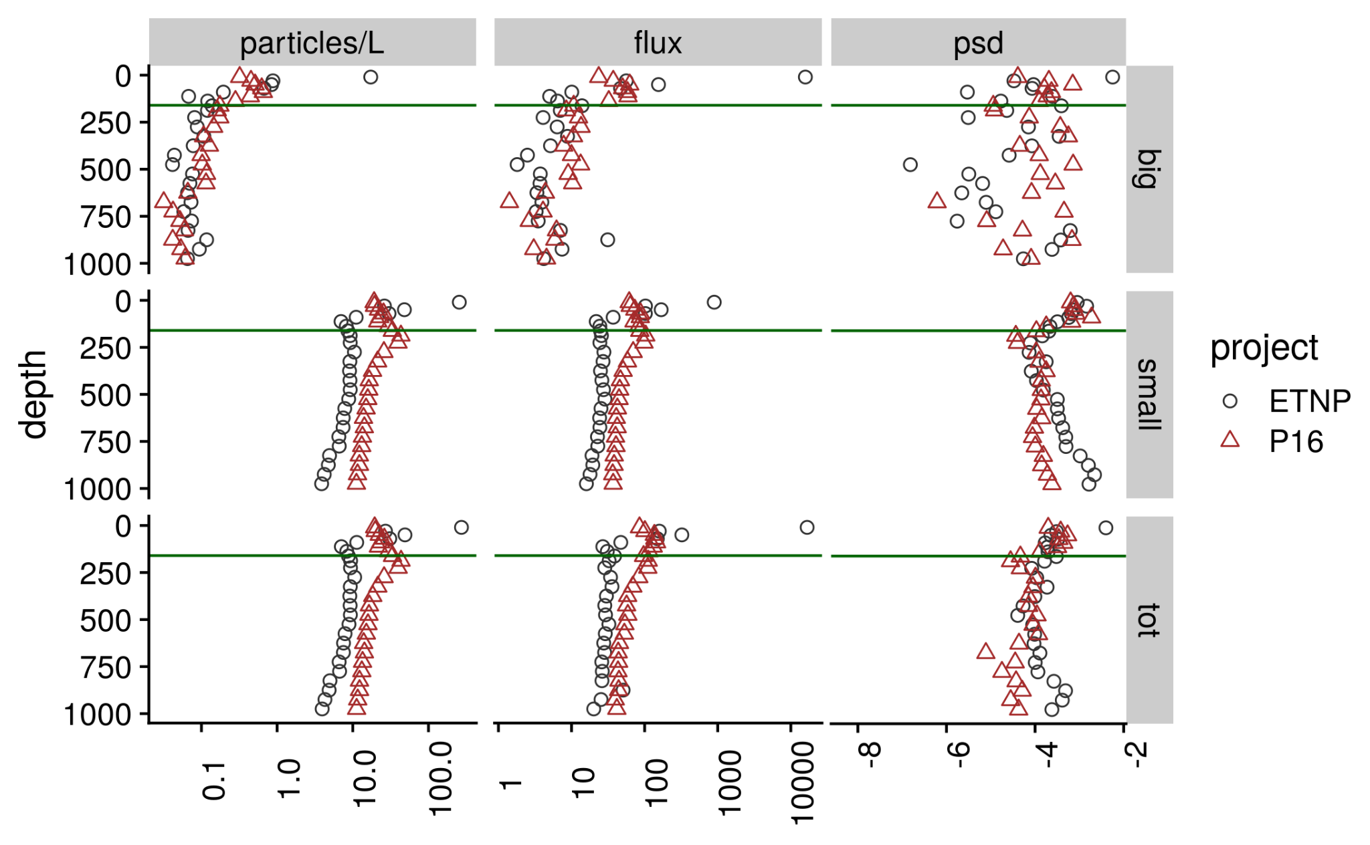 **Figure S8.** Depth binned particle number (volume normalized), particle size slope (PSD), and flux (estimated as in Fig. 4) for large ($>=500 μm$), small ($<500 μm$) and total particles, at the oxic and anoxic site

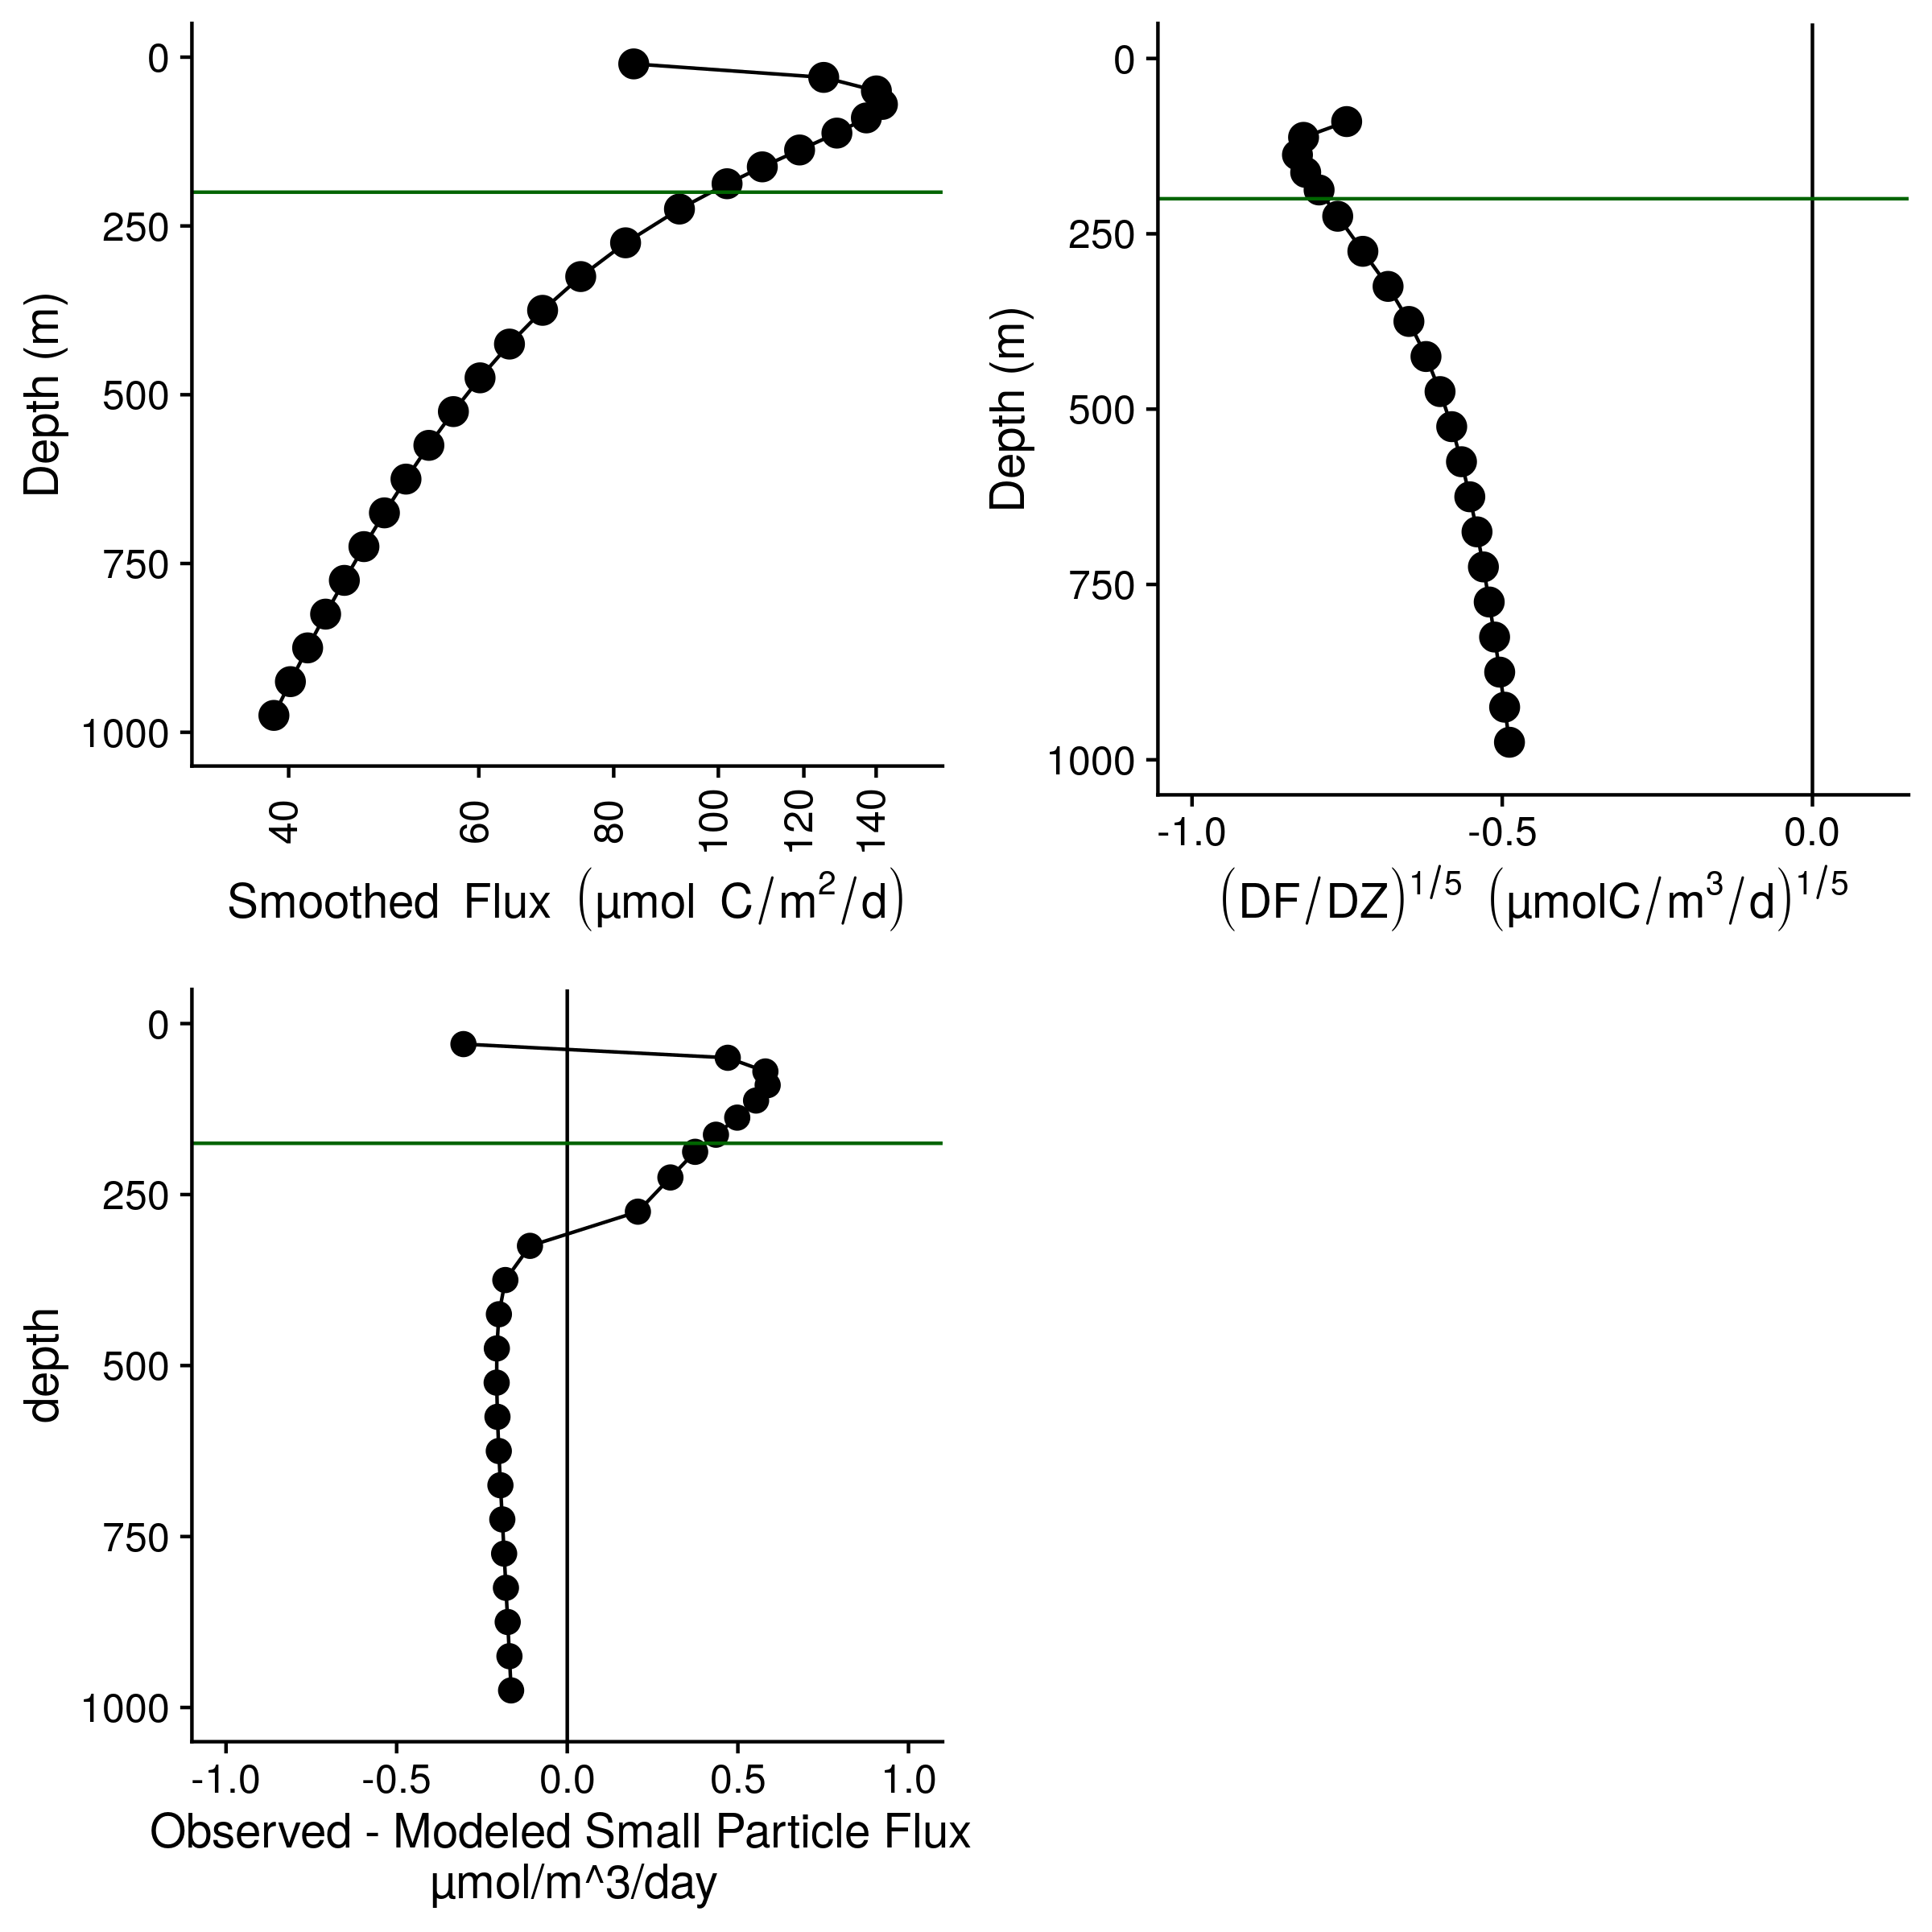 **Figure S9.** Flux profiles and flux attenuation at P16 Station 100. **(A)** Flux profile **(B)** Fifth-root transformed depth normalized rate of flux decrease. **(C)** Difference between observed and modeled results. Higher values suggest more disaggregation-like processes.

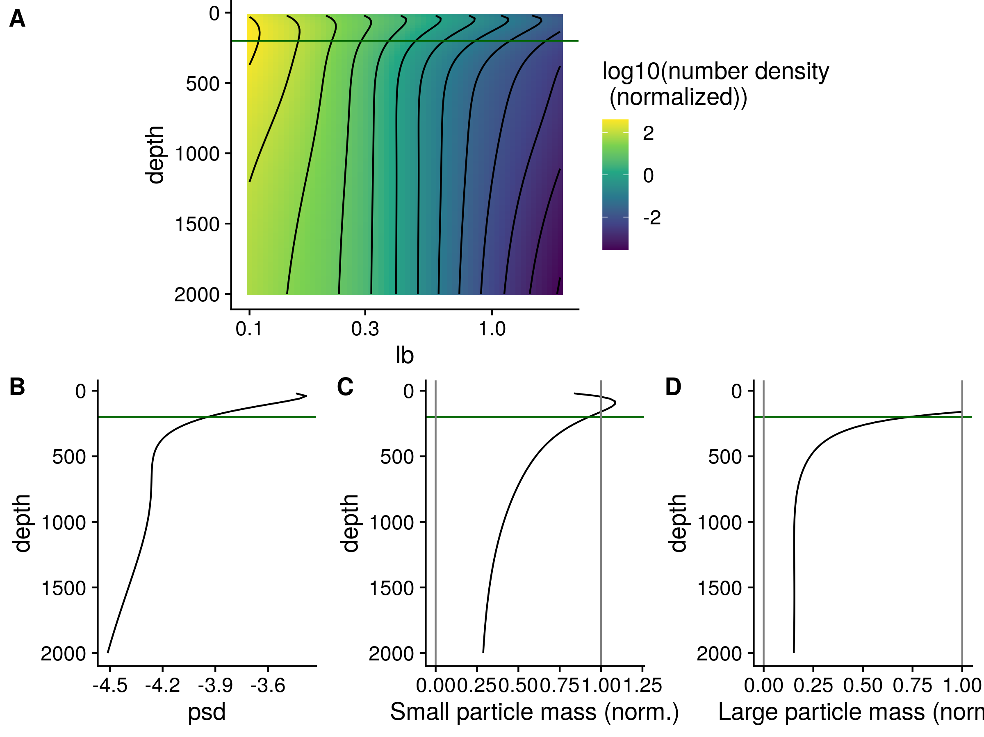 **Figure S10.** The same profiles as shown in Figure 5, but for the oxic site P16 Station 100. **(A)** GAM smoothed bin-size and volume particle numbers at each particle size class. **(B)** Particle size distributions. And estimated biomass of **(C)** Small and **(D)** Large particles.

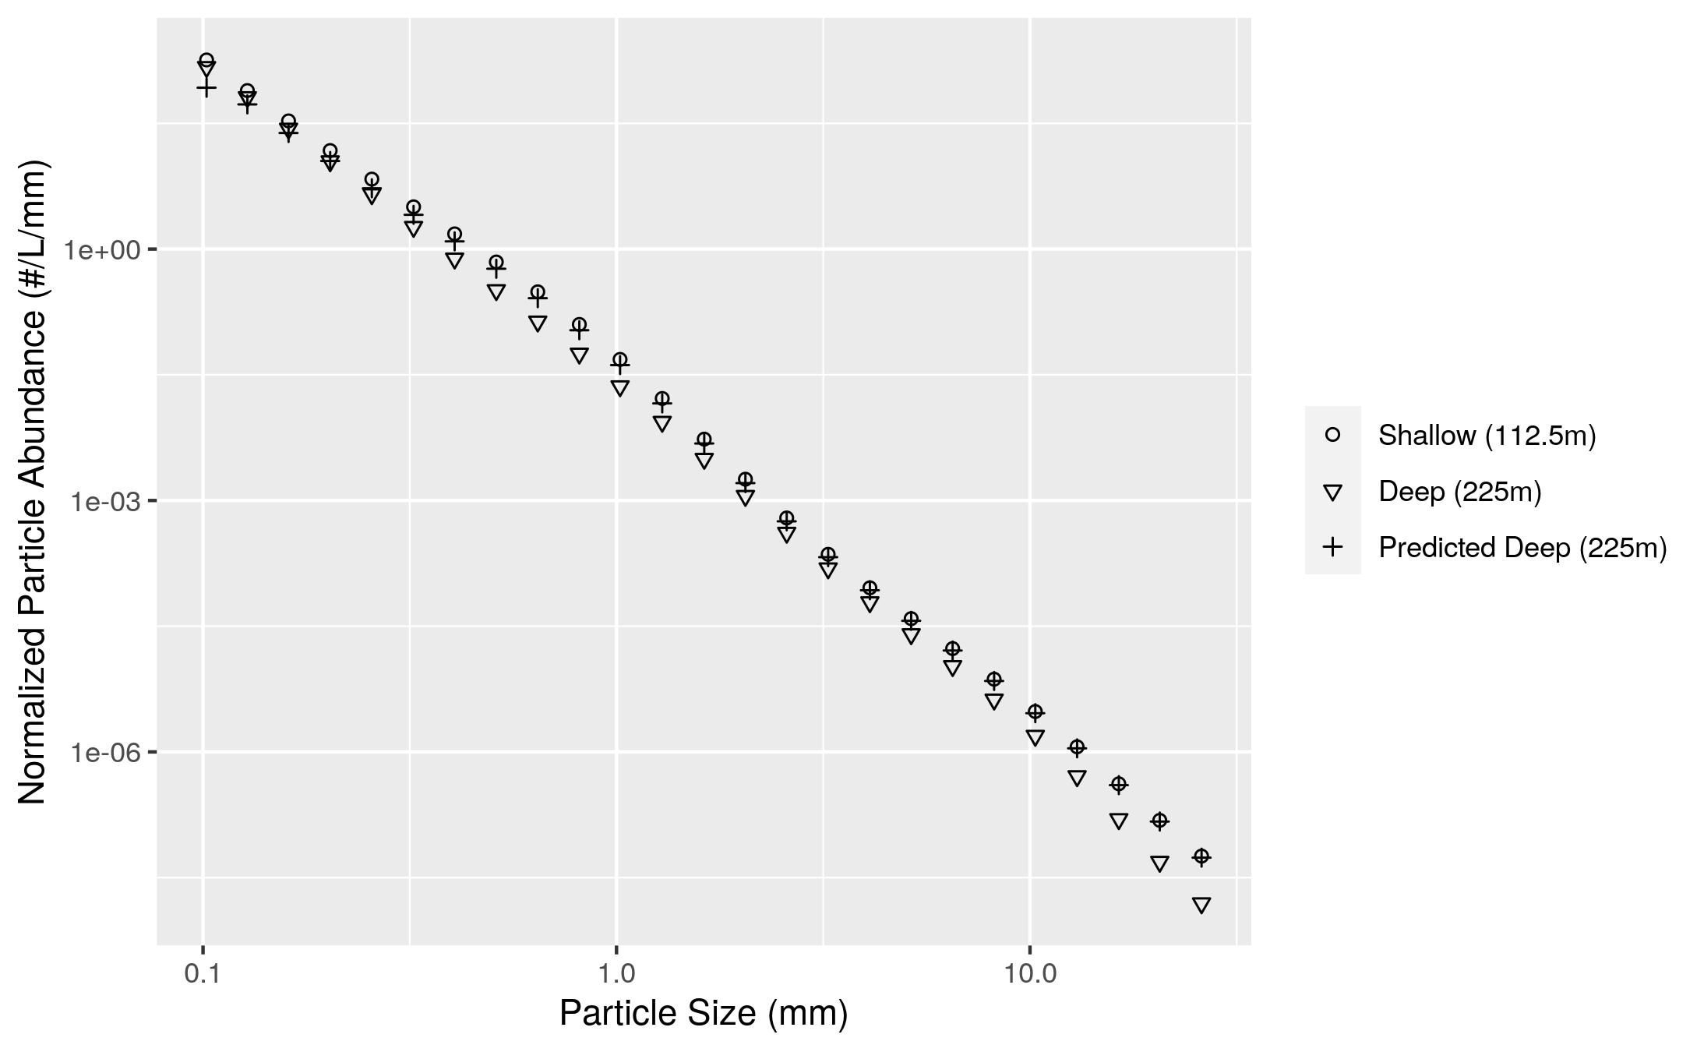

**Figure S11.** An example of differences between modeled and observed particle slope. The particle size distribution at a shallow and a deeper depth are shown. The model generates a prediction of the deep depth profile from the shallow depth profile and the flux attenuation between the two profiles. The model predicts more attenuation of the smallest particles than is actually observed. In practice the model compares depths that are closer together than the two shown here. In particular, the depth bin above 225m in our analysis has a midpoint of 187.5m, but we choose in this example to compare the 225m particle size profile to the profile at 112.5 m. Two depths that are far apart are shown so that the flux attenuation is large enough to be seen by eye and to provide a conceptual example of the models’ function.

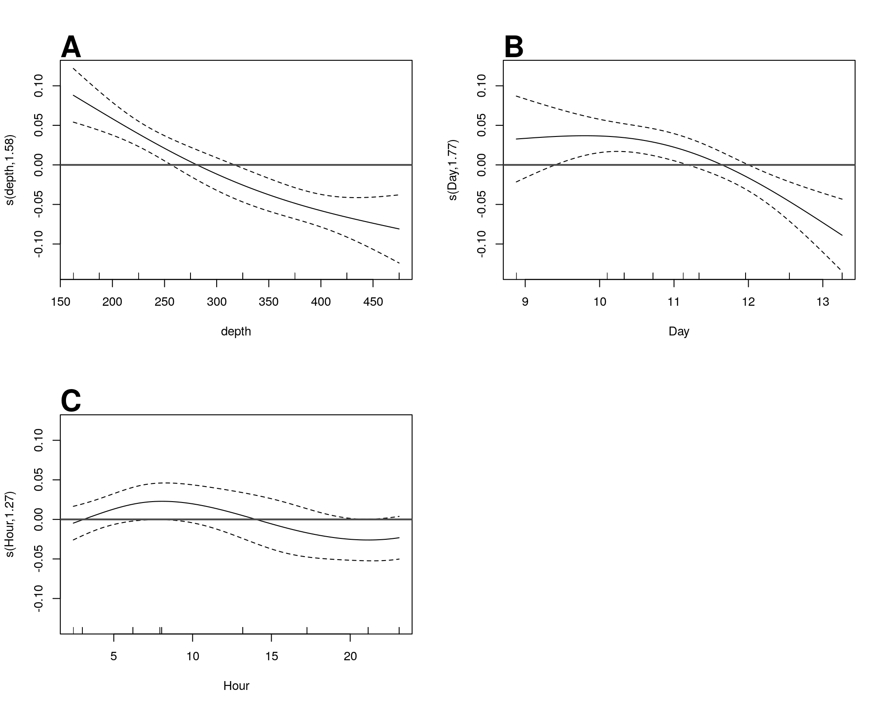

**Figure S12**. GAM predicted effects of **A** Depth, **B** Day of the month in January 2017. Y axis indicates the value of the component smooth functions effect on the difference between observed and modeled flux. Thus higher values correspond with greater flux of small particles than predicted by the model. Horizontal gray line indicates y = 0, corresponding to that parameter having zero effect, positive or on the outcome. Only Depth and Day have a statistically significant relationship to rate of change of flux (see section X).

Text S1. Full mathematical justification for the eularian version of the particle remineralization and sinking model (PRiSM) model. Ful document uploaded separately.